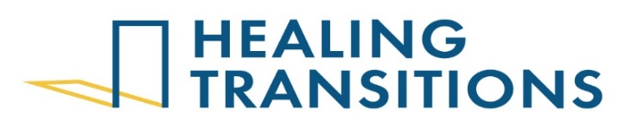
Annual Fund Manager
Full-Time, Exempt

Role Summary: The Annual Fund Manager will manage all activities related to fund development and annual giving in conjunction with all fundraising activities of the Board of Directors, staff, and volunteers. The major objective of the job is to develop and implement a comprehensive annual fundraising strategy that achieves department goals and all fundraising activities and programs in accordance with the mission, purpose, philosophy and values of Healing Transitions.

Core Responsibilities:
- Annual Giving
  - Plan, coordinate, and execute annual giving campaigns to meet $2.4M annual fundraising goal.
  - Create strategies around multi-channel solicitations including direct mail, peer to peer, and social media/e-newsletter appeals.
  - Cultivate and grow donor base, renewing and upgrading donor support, strengthening donor relationships, and collaborating with the team. Identify strategies to engage foundations, corporations, major donors, recurring donors, and new donors.
  - Provide support to the Development Committee.
  - Coordinate with the Development and Communications team to host successful and engaging fundraising events.
  - Serve as the primary grant writer and effectively prospect, write, and apply for grants.
  - Monitor and analyze campaign performance to optimize future efforts.
- Capital Campaigns
  - Provide support to Capital Campaign Committee members on their major fundraising initiatives and asks.
- Communicate the Mission and Value of the Organization
  - Effectively convey the organization's mission and values to stakeholders and the community.
  - Create compelling narratives and messaging that resonate with diverse audiences.
- Identify and Maintain Relationships with Stakeholders
  - Maintain strong relationships with existing donors and supporters.
  - Identify potential new donors and build relationships to expand the organization's support base.
  - Conduct research to identify prospects and develop targeted outreach strategies.
  - Recognize and appreciate donor contributions through personalized communication and stewardship activities.
- Exercise Appropriate Self-Care
  - Maintain personal well-being to effectively perform job responsibilities.
  - Manage workload and prioritize tasks to prevent burnout.
  - Seek support and resources as needed to maintain a healthy work-life balance.

Role Requirements and Preferences:
Required:
- Bachelor’s degree from an accredited university.
- 2 years development experience at a nonprofit organization.
- Excellent verbal, written, and interpersonal communication skills.
- Completion of onboarding within the first month of hire, which consists of completing a review of the policy and procedures manual, the employee handbook, review of benefits, and job shadowing or position is forfeited.
- Clean pre-employment drug test.
Preferred:
- 3-5 years development experience including annual fund management, events, grant writing and demonstrated ability to close gifts at $5,000 and higher.
- Advanced knowledge of fund development theories, principles, and procedures.
- Knowledge of donor customer relationship management (CRM) software.
- Demonstrated ability to work effectively with individuals from a wide variety of backgrounds ranging from people experiencing homelessness to high-wealth individuals, volunteers, and elected officials.
- Advanced knowledge of direct mail and online giving requirements and best practices.
- Familiarity with the Healing Transitions service model and the recovery process.

Compensation and Benefits:
Healing Transitions offers health benefits eligibility at the date of hire and a professional, unique work environment with opportunities for growth. The pay rate for this position is $19.38/hour.

Application Process:
To apply, please complete an application for employment. Applications may be obtained from the reception desk at the men’s campus or detox desk at the women’s campus. Completed applications should be forwarded to Chanda Scott, HR Generalist at the men’s campus.

